AWS TASK -3

Task – 2 Launch two ec2-instances and connect it to a application load balancer, where the output traffic from the server must be an load balancer IP address

Steps: -
- Launching two EC2 instances.
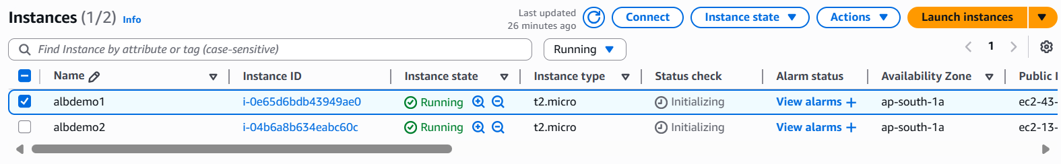

- Add Inbound Rules for Security group: -
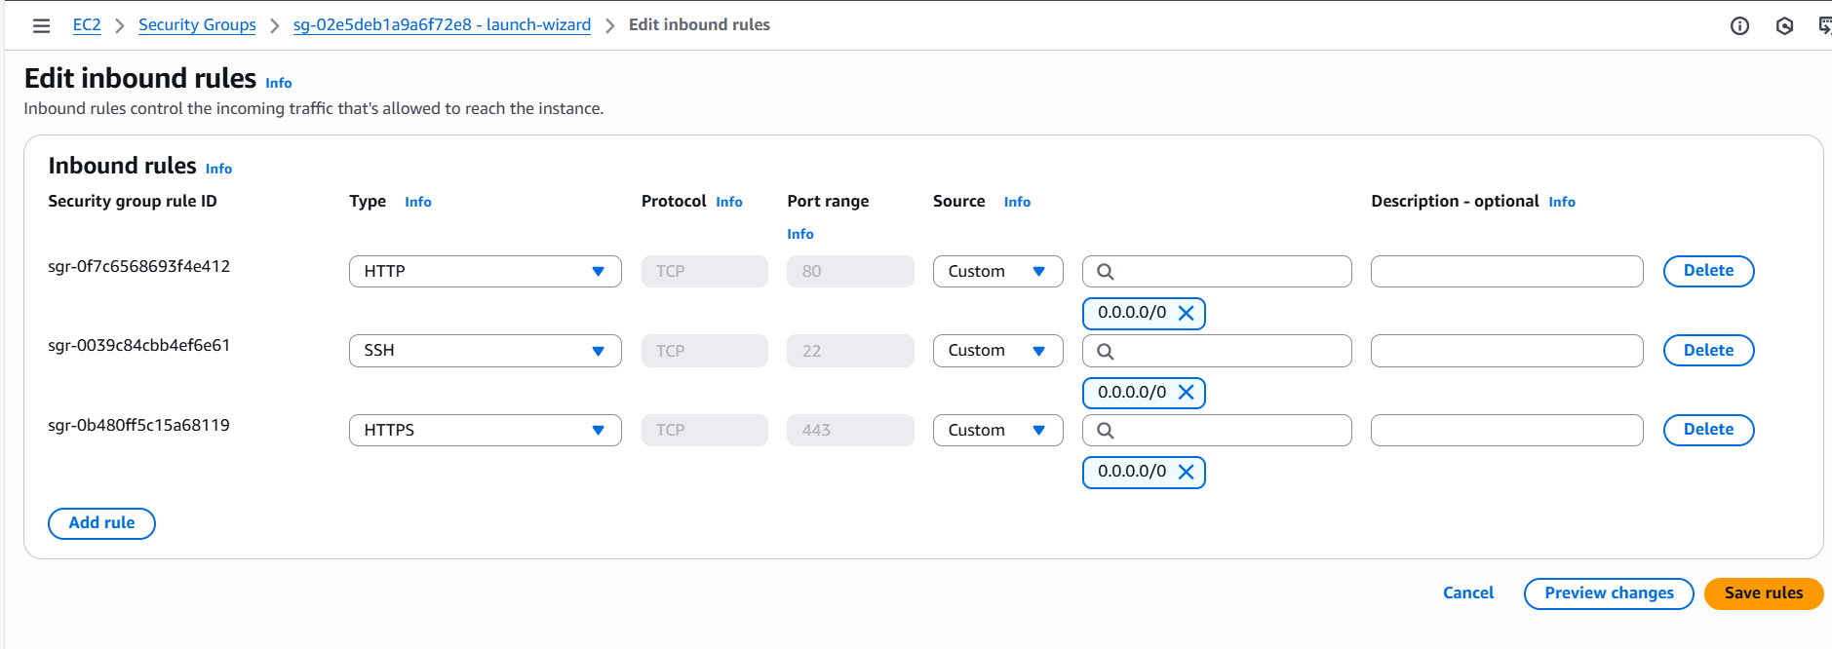

- Create Target Group: -
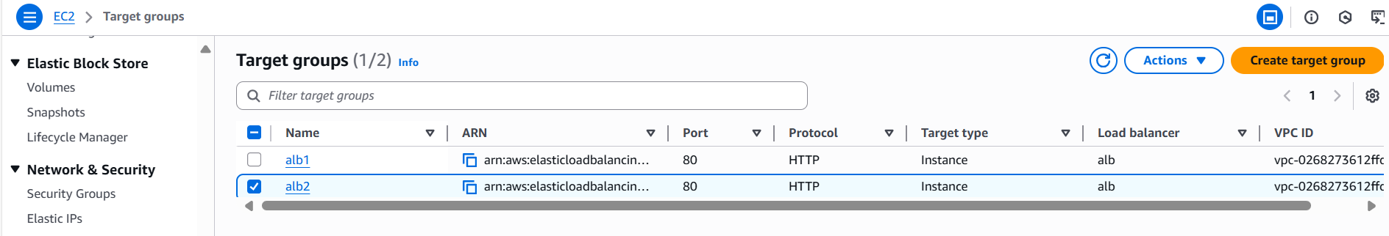

- Create Application Load Balancer: -
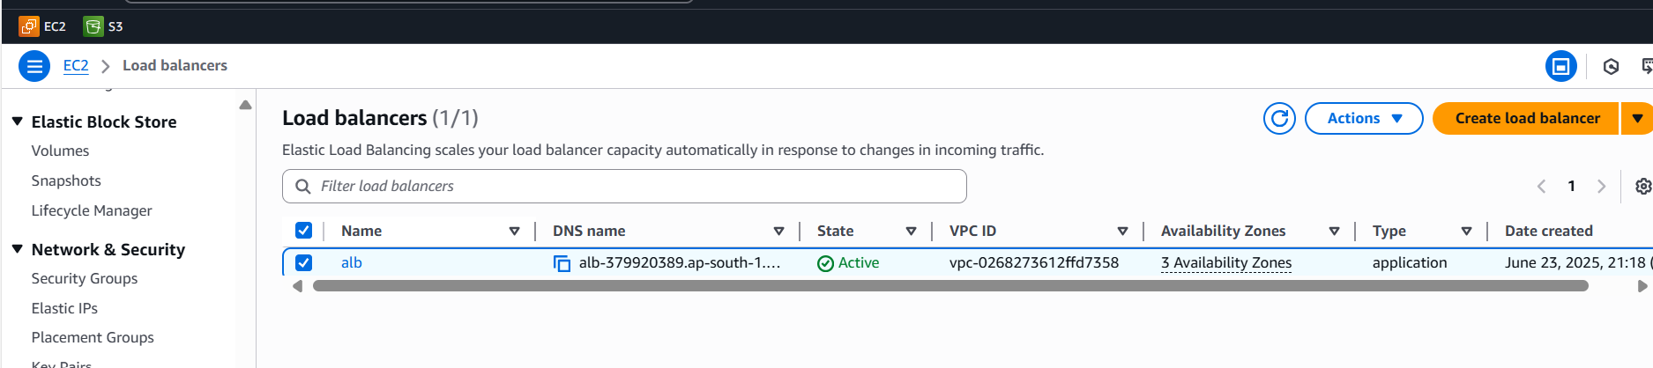
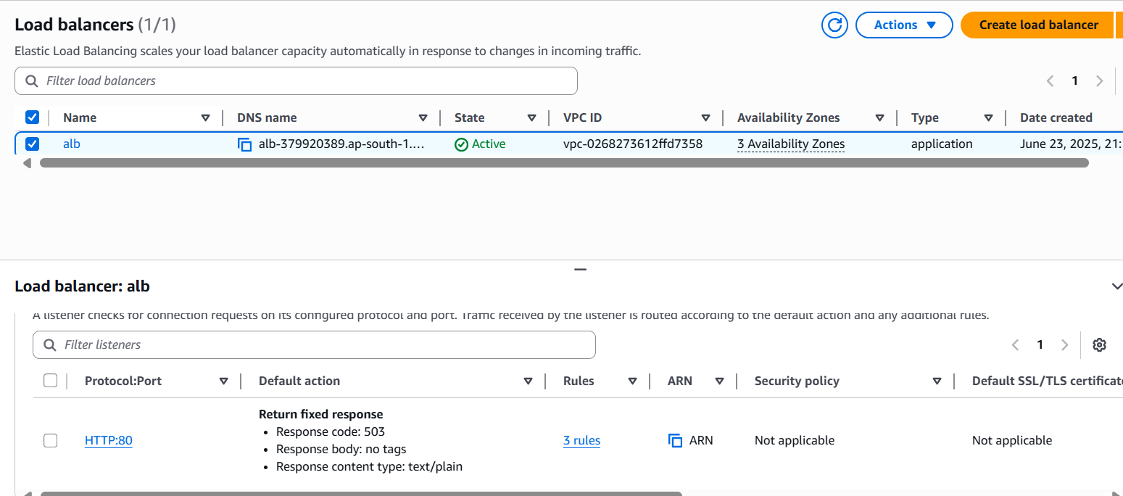

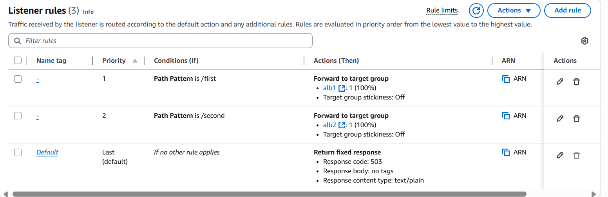

- Output Traffic of ALB: -
ALB 1
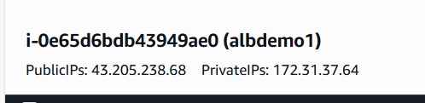
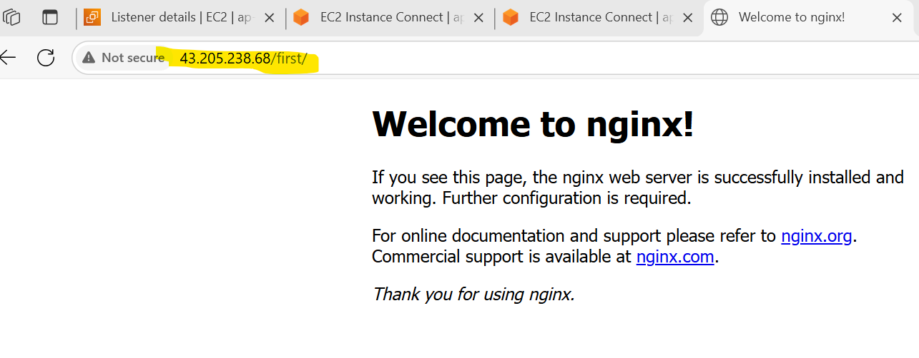

ALB 2
